**1) Find or Generate Your MailChimp API Key**

If you want to set up integration with your MailChimp account, you'll need to generate an API key or grab an existing one.  
1. Sign in to MailChimp and click your profile name to expand the Account Panel, and choose **Account**.  
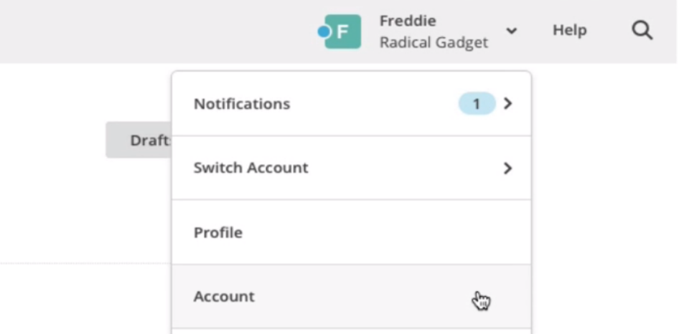  
2. Click the **Extras** drop-down menu and choose **API keys**.

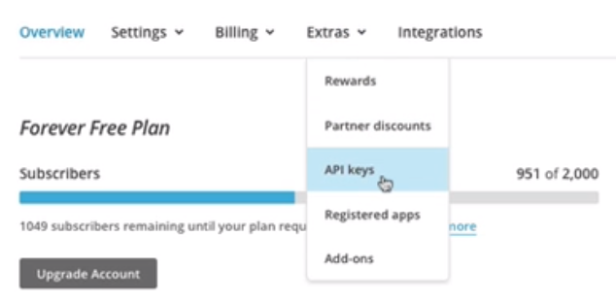  
3. Copy an existing API key or click the **Create A Key** button.   
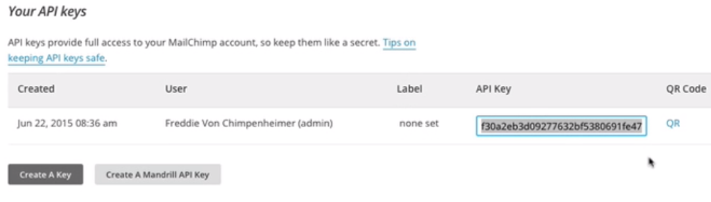   
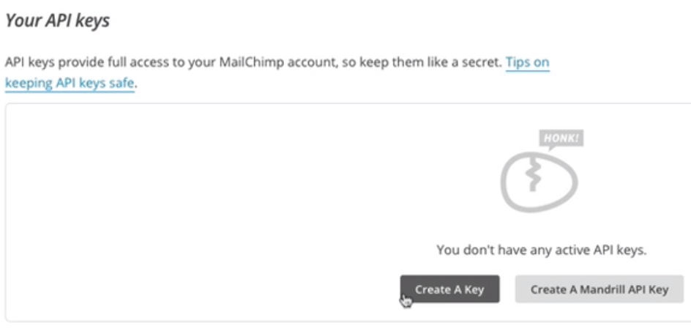  
4. Paste it in the MailChimp Key field

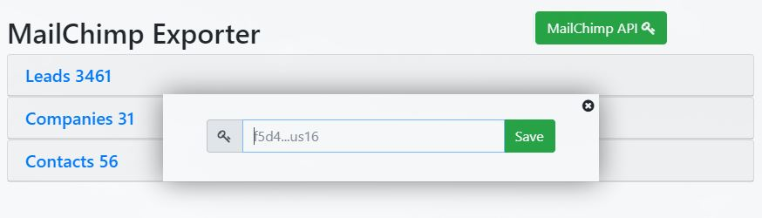

**2) Create a New List in MailChimp**

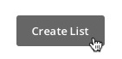A powerful part of MailChimp is your list, which stores your contacts' email addresses and other valuable information. Each time you create a new list, you'll be prompted to input default information like your From email address and a message to remind your contacts who you are. To create a new list in your MailChimp account, follow these steps.

Navigate to the **Lists** page and click **Create List**.

In the **New list or groups?** box, click **Create List**.   
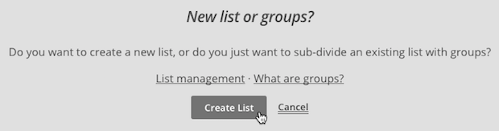  
Type in the **List details** in the fields provided.   
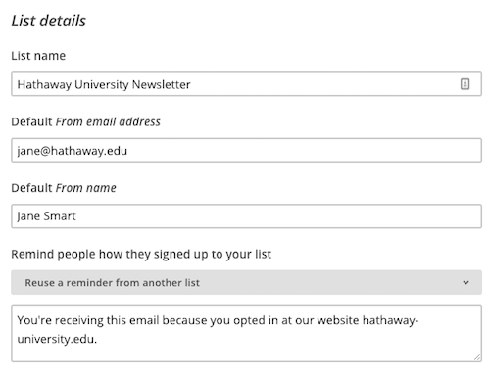

Review the **Contact information for this list**, and edit if necessary.

In the **Form Settings** section, choose the signup method for your list.   
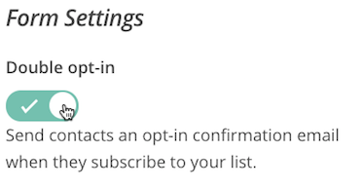  
Toggle the **Double opt-in** slider to the green checkmark to send an opt-in confirmation email when someone signs up to your list. Or, **leave it unchecked** to use single opt-in and add subscribers to your list right away.

Enter the email address where you'd like to receive notifications about your list, and select your notifications.   
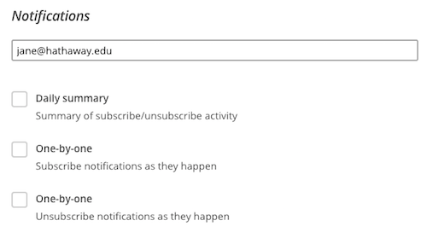

When you're finished, click **Save**.

After you create your list, you'll be able to [import subscribers](http://kb.mailchimp.com/lists/growth/import-subscribers-to-a-list) or [set up a signup form](http://kb.mailchimp.com/lists/signup-forms/how-the-form-builder-works) to collect new contacts.   
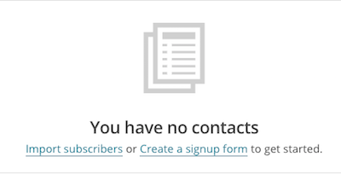

**3) Video Guide - Bitrix24 to Mailchimp Lead export process**

**https://youtu.be/tga6uEeWM5w**

**4) Support**

If you have questions, write to us: [support@webbee.co.nz](mailto:support@webbee.co.nz) or [Live-chat](https://webbee.bitrix24.com/online/webbee-live-chat)   
The commercial subscription will be activated after one month of using the service.

App's official website page: <http://webbee.co.nz/crm-solutions/cases/bitrix24-to-mailchimp-integration-application/>

Support hours: 09:00 - 18:00 NZMT time (GMT +12:00) daily except weekend. Response time: 24 hours